Building Subgraphs in LangGraph
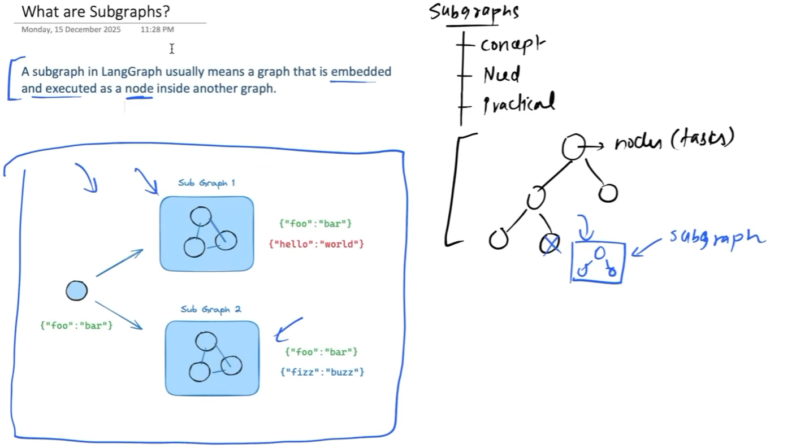
A single node can contain many tools, evaluations, guardrails, and other operations, making the node too complex. We divide this functionality into subgraphs to make the workflow more granular and easier to manage.
Intuition:
Instead of having one huge worker doing everything, we divide the work among smaller teams, where each team handles a specific responsibility.
Subgraphs are useful in LangGraph for failure isolation, separate state management, and better observability.
Explanation:
- Failure Isolation → If one subgraph fails, the other subgraphs do not necessarily have to shut down and can continue working.
- Separate State → Each subgraph can have its own state, instead of having a single state managing all the data of a large program.
- Better Observability → Subgraphs make the workflow more granular, allowing us to trace and monitor each subgraph separately, which makes debugging and understanding the workflow easier. Its done using langsmith.
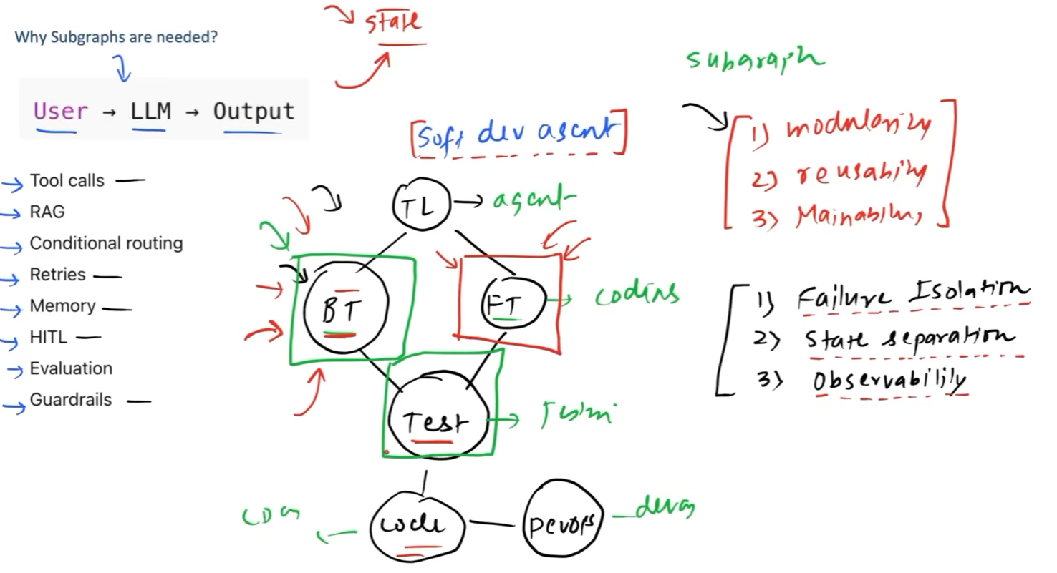
There are basically two ways to integrate a subgraph into the main graph.
Explanation:
- Invoke the subgraph through a node → Create a node inside the main graph that explicitly calls/invokes the subgraph.
- Add the subgraph directly to the main graph → Include the entire subgraph as part of the main graph itself.
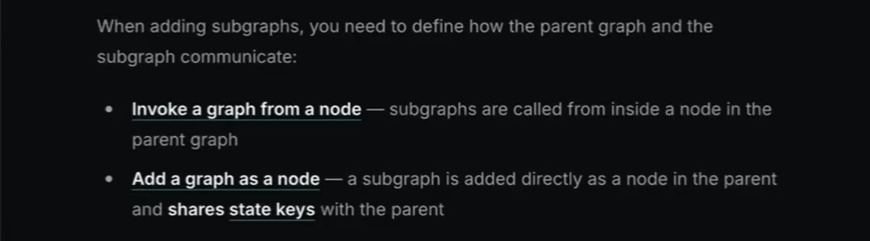
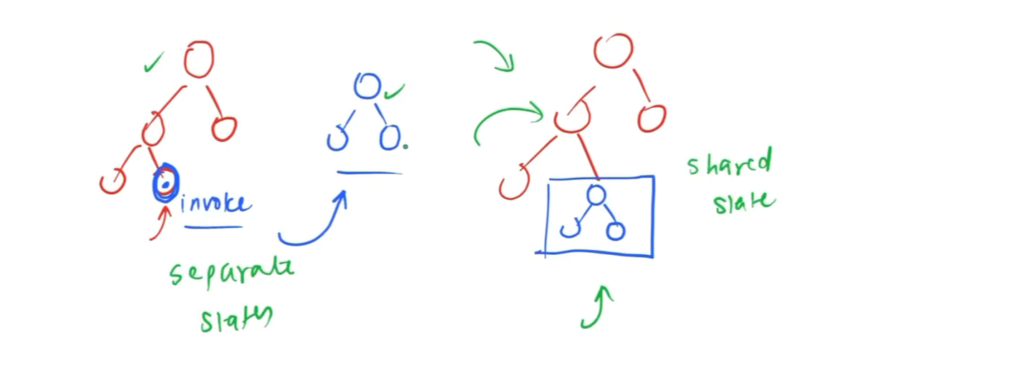
The main difference is how state is managed between the main graph and the subgraph.
Explanation:
- Subgraph invoked through a node → We have two separate states: one for the main graph and one for the subgraph.
- Subgraph added directly to the main graph → We have one shared state that is used by both the main graph and the subgraph.
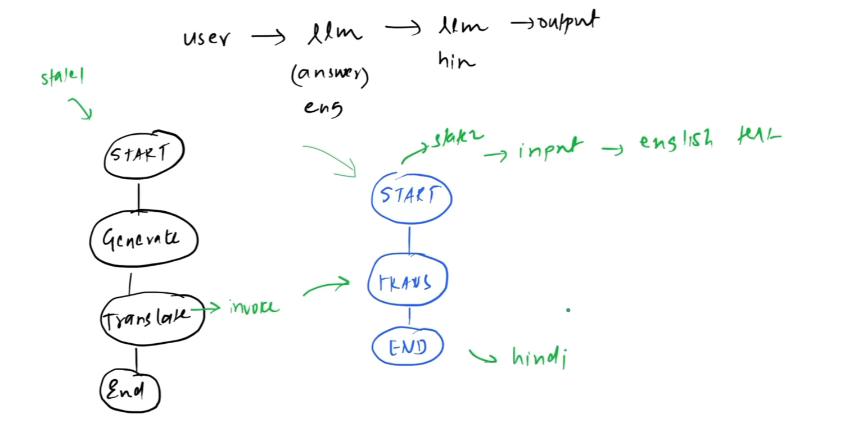

Code:- This is the code where the translate node calls another graph (subgraph).
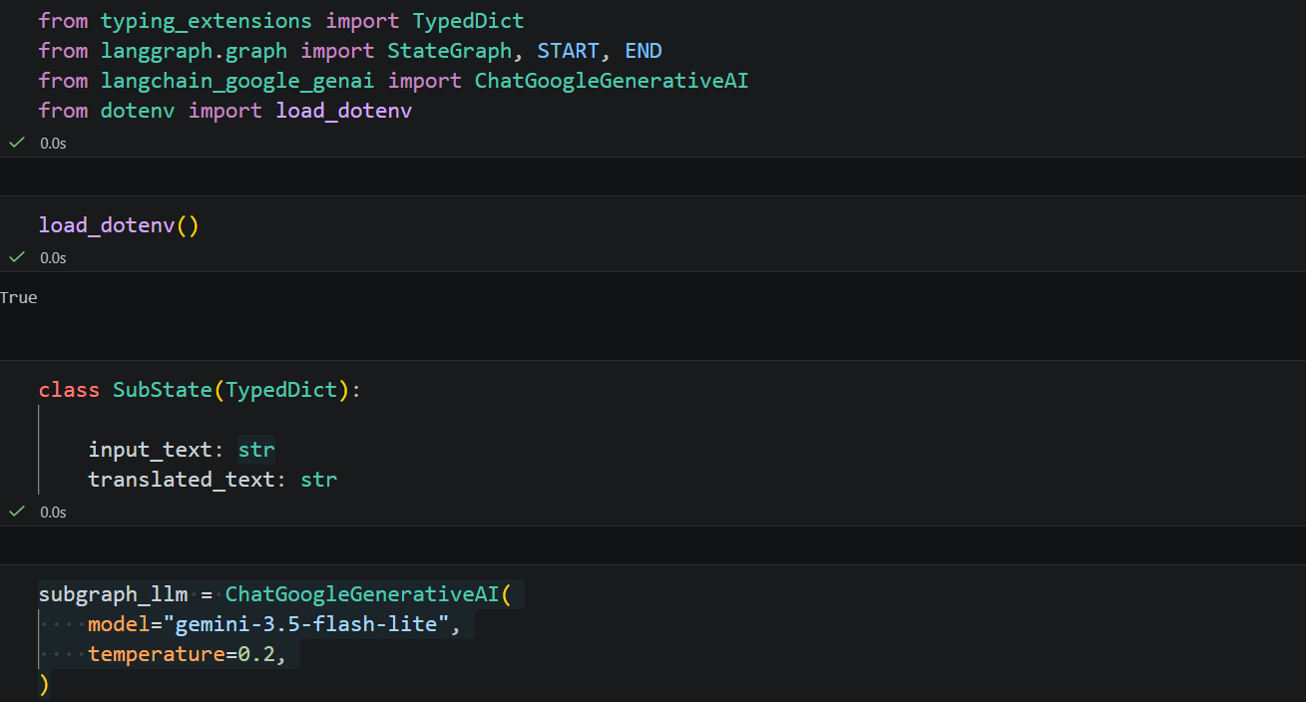
We created subgraph here.
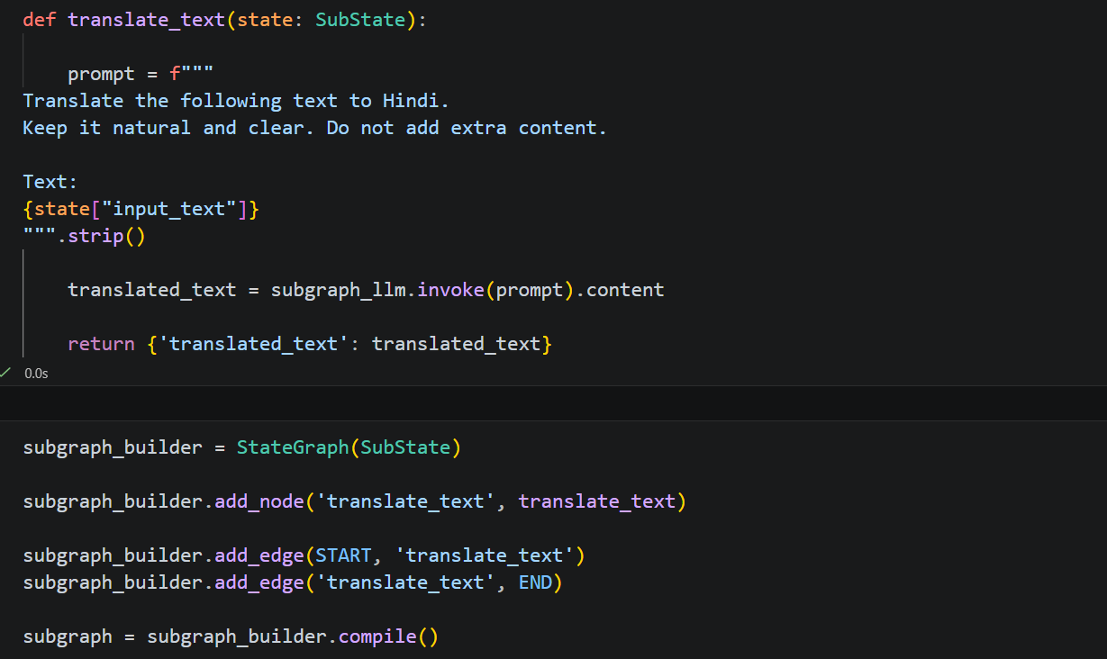

We create a parentState for the main/parent graph, which defines the state that will be shared between the nodes of the parent graph.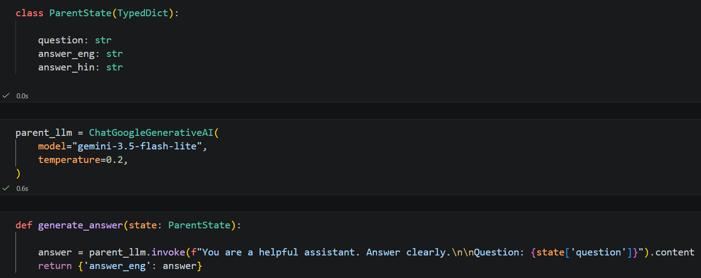

This is the node where we call subgraph.invoke() to invoke another graph (subgraph) instead of performing the task directly within the current node
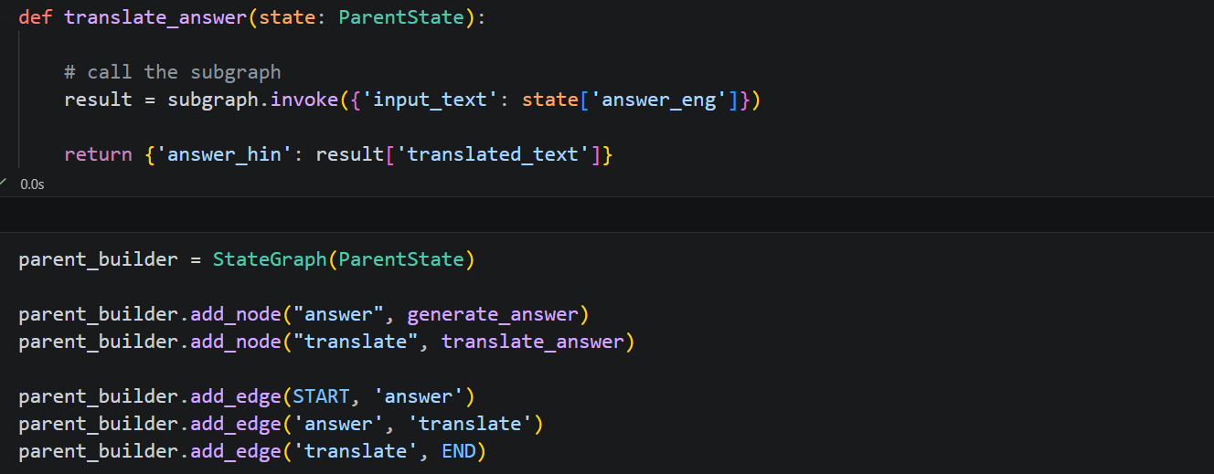
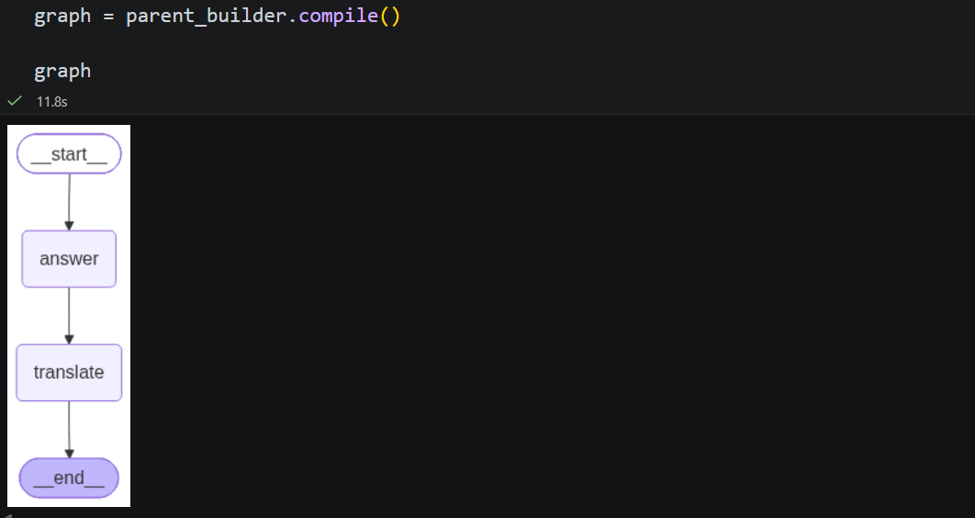
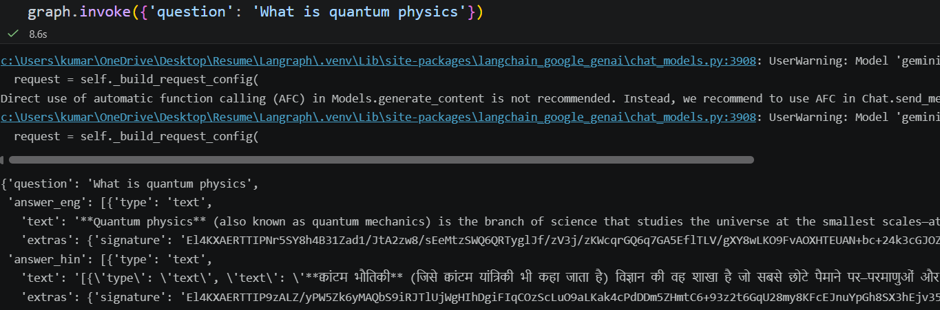

Code:- Here, we are basically creating the subgraph inside the main graph itself. In this approach, the subgraph uses the same shared state as the main graph.
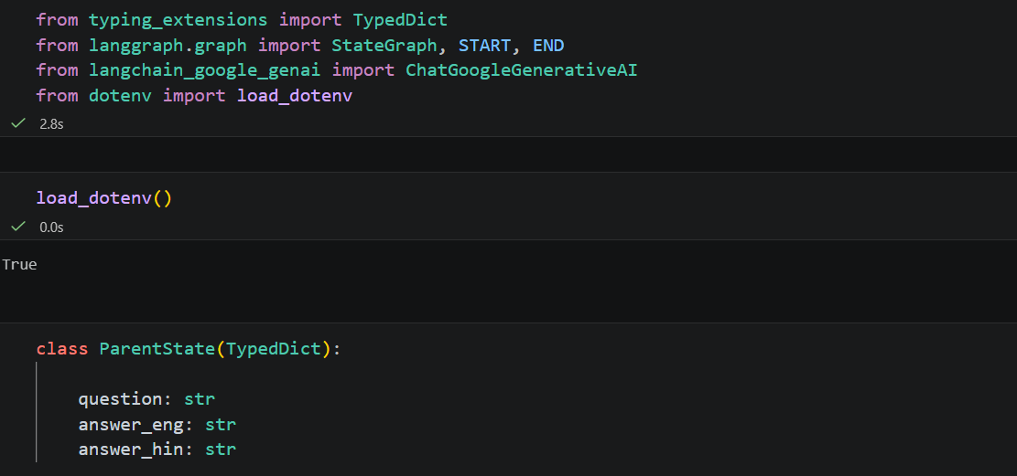
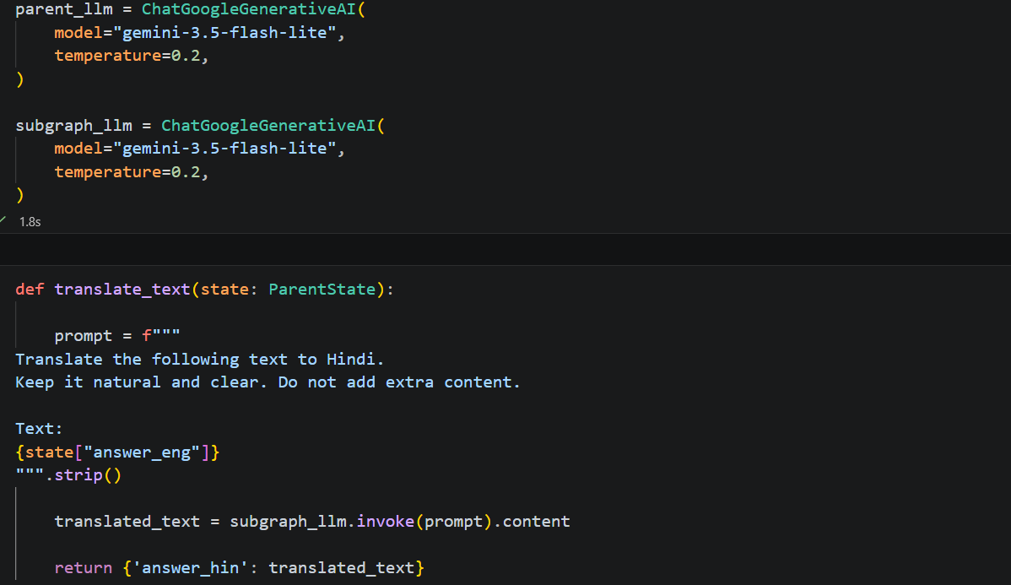

Apart from not having a separate state for the subgraph, everything is the same as before, such as creating a graph for translation. However, in this approach, we create only one node in the parent graph, and we do not create a separate translate node.
Instead of passing a node function to add_node(), we pass the name of the subgraph, which is subgraph in this case. That is the main difference.